Министерство науки и высшего образования Российской Федерации
Муромский институт (филиал)
Федерального государственного бюджетного образовательного учреждения высшего образования
«Владимирский государственный университет
имени Александра Григорьевича и Николая Григорьевича Столетовых»

Факультет ИТР
Кафедра ПИн

ЛАБОРАТОРНАЯ
РАБОТА №5

По Системам управления базами данных
Тема Работа с базой данных

Руководитель
Колпаков А.А.
(фамилия, инициалы)

(подпись) (дата)

Студент ПИн – 121
(группа)
Ермилов М.В.
(фамилия, инициалы)

(подпись) (дата)

Муром 2023
Лабораторная работа № 5
Задания
- Отобразить на форме все таблицы из базы данных (с использованием и без использования SQL).
- Выполнить выборку определенных полей и записей (с использованием и без использования SQL).
- В приложении использовать связные, посредством свойств компоненов, таблицы и компонент BindingNavigator.
- При выводе записи сортировать по возрастанию или убыванию.
- Осуществить выборку одновременно из нескольких таблиц на один визуальный компонент.
6. Реализовать изменение/удаление/добавление записей
Листинг кода:
<?php
function UserCreate(int $phone_code, int $phone, string $password, string $name, string $surname, DateTime $birth): int {
DataBaseRequest("INSERT INTO `user_login` (`phone_code`, `phone`, `password`) VALUE ({$phone_code}, {$phone}, '{$password}')");
$user = DataBaseGetInsertId();

$wall = WallCreate(user: $user);
$photo = PhotoAlbumCreate(user: $user);
$dateBirth = $birth->format('Y-m-d');
DataBaseRequest("INSERT INTO `user` (`id`, `name`, `surname`, `date_birth`, `wall`, `photo`) VALUE ('{$user}','{$name}','{$surname}','{$dateBirth}', {$wall}, {$photo})");
LogCreate(0, $user);
return $user;
}
?>
<?php
function UserGet(int $id) : null {
$r = DataBaseGetLine("SELECT * FROM `user` WHERE `id` = {$id} LIMIT 1;");
if(isset($r)) {

}
return null;
}

function UserGetGroups(int $user){
return DataBaseGetArray("SELECT `id` FROM `group_list` WHERE `user` = {$user} AND `type` > 0;");
}
function UserGetGroupsAdmin(int $user){
return DataBaseGetArray("SELECT `id` FROM `group_list` WHERE `user` = {$user} AND `type` = 3;");
}
function UserGetGroupsEditor(int $user){
return DataBaseGetArray("SELECT `id` FROM `group_list` WHERE `user` = {$user} AND `type` > 1;");
}
function UserGetGroupsOwner(int $user){
return DataBaseGetArray("SELECT `id` FROM `group` WHERE `owner` = {$user} AND `date_delet` = 0;");
}

function UserIsDelet(int $user){
$data = DataBaseGetLine("SELECT * FROM `user` WHERE `id` = {$user} AND `date_delet` = 0 LIMIT 1;");
return !isset($data);
}

?>
<?php
/**
* Первая часть регистрации
* @param int $phone_code Код страны из базы данных
* @param int $phone Номер телефона, без кода страны
* @param string $password Пароль
* @param string $name Имя
* @param string $surname Фамилия
* @param string $date_birth Дата рождения
*/
function UserRegistration(int $phone_code, int $phone, string $password, string $name, string $surname, string $date_birth): int {
if(DataBaseGetLine("SELECT COUNT(*) AS `count` FROM `code` WHERE `id` = {$phone_code}")["count"] == 1) {
$code = DataBaseGetLine(
"SELECT
(SELECT COUNT(*) FROM `user_login` WHERE `phone_code` = {$phone_code} AND `phone` = {$phone}) AS `count1`,
(SELECT COUNT(*) FROM `registration` WHERE `phone_code` = {$phone_code} AND `phone` = {$phone}) AS `count2`"
);
if($code["count1"] == 0 && $code["count2"] == 0) {
$code = RandomCode();
$_code = GetHash($code);
$_password = GetHash($password);
DataBaseRequest("INSERT INTO `registration` (`phone_code`, `phone`, `name`, `surname`, `date_birth`, `password`, `code`) VALUES ({$phone_code},{$phone},'{$name}','{$surname}','{$date_birth}','{$_password}','{$_code}');");
SendSMS($phone_code, $phone, "confirmation code: ".$code);
return 0;
} else {
return 3;
}
} else {
return 2;
}
}
/**
* Подтверждение регистрации
* @param int $phone_code Код страны из базы данных
* @param int $phone Номер телефона, без кода страны
* @param string $code Код подтверждения регистрации
*/
function UserRegistrationConfirm(int $phone_code, int $phone, string $code): int {
$codes = GetHash($code);
$data = DataBaseRequest("SELECT * FROM `registration` WHERE `phone_code`={$_POST["phone_code"]} AND `phone` = {$_POST["phone"]} AND `code` = {$codes} LIMIT 1;");

if(mysqli_num_rows($data) == 1) {
DataBaseRequest("DELETE FROM `registration` WHERE `phone_code`={$_POST["phone_code"]} AND `phone` = {$_POST["phone"]} LIMIT 1;");
$data = mysqli_fetch_array($data);
$user = UserCreate($data["phone_code"], $data["phone"], $data["password"], $data["name"], $data["surname"], $data["date_birth"]);
SessionOpen($user);
return 0;
} else {
return 4;
}
}
?>
<?php
function UserUpdate(int $user, string|null $name = null, string|null $surname = null, DateTime|null $birth = null, string|null $status, int|null $icon, int|null $cover) {
$_user = DataBaseGetLine("SELECT * FROM `user` WHERE `id` = {$user} AND `date_delet` = 0 LIMIT 1;");
if(isset($_user))
{
$type = $_user['type'];
$data = "";
if(isset($name) && $type % 2 == 0) {
$data = "`name` = '{$name}'";
LogUpdate(0, $user, $name);
}
if(isset($surname) && $type % 2 == 0) {
if($data != "") {
$data .= ", ";
}
$data = "`surname` = '{$surname}'";
LogUpdate(1, $user, $surname);
}
if(isset($birth) && $type % 2 == 0) {
$dateBirth = $birth->format('Y-m-d');
if($data != "") {
$data .= ", ";
}
$data = "`date_birth` = '{$dateBirth}'";
LogUpdate(2, $user, $dateBirth);
}
if(isset($status)) {
if($data != "") {
$data .= ", ";
}
$data = "`status` = '{$status}'";
LogUpdate(3, $user, $status);
}
if(isset($icon)) {

if($data != "") {
$data .= ", ";
}
$data = "`icon` = {$icon}";
LogUpdate(4, $user, $icon);
}
if(isset($cover)) {

if($data != "") {
$data .= ", ";
}
$data = "`cover` = {$cover}";
LogUpdate(5, $user, $cover);
}
if($data != "") {
DataBaseRequest("UPDATE `user` SET {$data} WHERE `id` = {$user} LIMIT 1;");
}
}
}
?>
<?php
function UserInteractiveCountFriends(int $user): int {
return DataBaseGetLine("SELECT COUNT(*) AS `count` FROM `user_interactive` WHERE (`user_1` = {$user} OR `user_2` = {$user}) AND `type` = 3;")['count'];
//return count(UserInteractiveGetFriends($user));
}
function UserInteractiveCountSubscribers(int $user): int {
return DataBaseGetLine("SELECT COUNT(*) AS `count` WHERE (`user_1` = {$user} AND `type` = 2) OR (`user_2` = {$user} AND `type` = 1);")['count'];
//return count(UserInteractiveGetSubscribers($user));
}
function UserInteractiveCountSubscriptions(int $user): int {
return DataBaseGetLine("SELECT COUNT(*) AS `count` WHERE (`user_1` = {$user} AND `type` = 1) OR (`user_2` = {$user} AND `type` = 2);")['count'];
//return count(UserInteractiveGetSubscriptions($user));
}
function UserInteractiveCountBlocks(int $user): int {
return DataBaseGetLine("SELECT COUNT(*) AS `count` WHERE (`user_1` = {$user} AND (`type` = -1 OR `type` = -3)) OR (`user_2` = {$user} AND (`type` = -2 OR `type` = -3));")['count'];
//return count(UserInteractiveGetBlocks($user));
}
?>
<?php
function UserInteractiveGetFriends(int $user): array|null {
return DataBaseGetArray("SELECT `user_2` AS `id` FROM `user_interactive` WHERE `user_1` = {$user} AND `type` = 3
UNION
SELECT `user_1` AS `id` FROM `user_interactive` WHERE `user_2` = {$user} AND `type` = 3;");
}
function UserInteractiveGetSubscribers(int $user): array|null {
return DataBaseGetArray("SELECT `user_2` AS `id` FROM `user_interactive` WHERE `user_1` = {$user} AND `type` = 2
UNION
SELECT `user_1` AS `id` FROM `user_interactive` WHERE `user_2` = {$user} AND `type` = 1;");
}
function UserInteractiveGetSubscriptions(int $user): array|null {
return DataBaseGetArray("SELECT `user_2` AS `id` FROM `user_interactive` WHERE `user_1` = {$user} AND `type` = 1
UNION
SELECT `user_1` AS `id` FROM `user_interactive` WHERE `user_2` = {$user} AND `type` = 2;");
}
function UserInteractiveGetBlocks(int $user): array|null {
return DataBaseGetArray("SELECT `user_2` AS `id` FROM `user_interactive` WHERE `user_1` = {$user} AND `type` = (`type` = -1 OR `type` = -3)
UNION
SELECT `user_1` AS `id` FROM `user_interactive` WHERE `user_2` = {$user} AND `type` = (`type` = -2 OR `type` = -3);");
}
function UserInteractiveGet(int $user1, int $user2): int|null {
if($user1 != $user2) {
if($user1 < $user2) {
$a = $user1;
$user1 = $user2;
$user2 = $a;
}
$r = DataBaseGetLine("SELECT * FROM `user_interactive` WHERE `user_1` = {$user1} AND `user_2` = {$user2} LIMIT 1;");
if(isset($r) && $r != false) {
return $r["type"];
}
}
return null;
}
?>
<?php
function UserInteractiveSet(int $user1, int $user2, int $type) {
static $InteractiveState = [
1 => [ 0 => 1, 2 => 3 ],
-1 => [ 0 => 2, 1 => 3 ],
2 => [ 1 => 0, 3 => 2 ],
-2 => [ 2 => 0, 3 => 1 ],
3 => [ -2 => -3, 0 => -1, 1 => -1, 2 => -1, 3 => -1 ],
-3 => [ -1 => -3, 0 => -2, 1 => -2, 2 => -2, 3 => -2 ],
4 => [ -3 => -2, -1 => 0 ],
-4 => [ -3 => -1, -2 => 0 ]
];
if($user1 != $user2 && 0 < $type && $type < 5) {
if($user1 < $user2) {
$a = $user1;
$user1 = $user2;
$user2 = $a;
$type *= -1;
}
$typeNow = UserInteractiveGet($user1, $user2);
$status = null;
if(isset($typeNow) && isset($InteractiveState[$type][$typeNow])) {
$status = $InteractiveState[$type][$typeNow];
} elseif(!isset($typeNow) && isset($InteractiveState[$type][0])) {
$status = $InteractiveState[$type][0];
}

if(isset($status)) {
if(isset($typeNow)) {
//if($status == 0) {
//DataBaseRequest("DELETE FROM `user_interactive` WHERE `user_1` = {$user1} AND `user_2` = {$user2} LIMIT 1;");
//} else {
DataBaseRequest("UPDATE `user_interactive` SET `type` = {$status} WHERE `user_1` = {$user1} AND `user_2` = {$user2} LIMIT 1;");
//}
} else {
DataBaseRequest("INSERT INTO `user_interactive` (`user_1`, `user_2`, `type`) VALUE ({$user1}, {$user2}, {$status});");
}
LogInteractive($user1, $user2, $type);
}
}
}

function UserInteractiveAddFriend($user1, $user2) {UserInteractiveSet($user1, $user2, 1);}
function UserInteractiveRemoveFriend($user1, $user2) {UserInteractiveSet($user1, $user2, 2);}
function UserInteractiveBlock($user1, $user2) {UserInteractiveSet($user1, $user2, 3);}
function UserInteractiveUnblock($user1, $user2) {UserInteractiveSet($user1, $user2, 4);}
?>
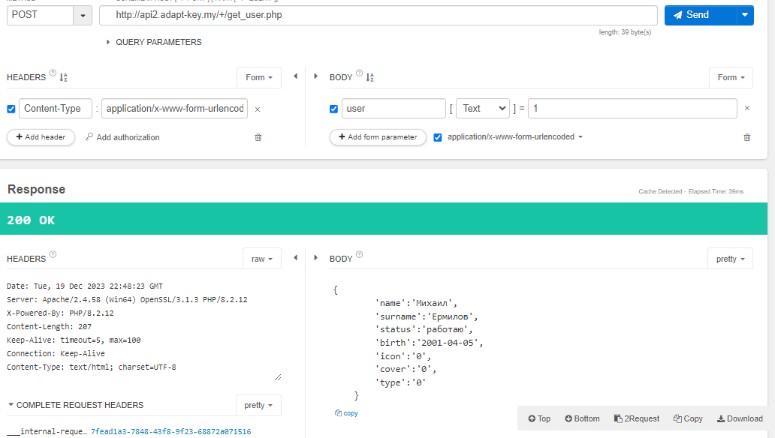
Рисунок 1 - пример работы программы

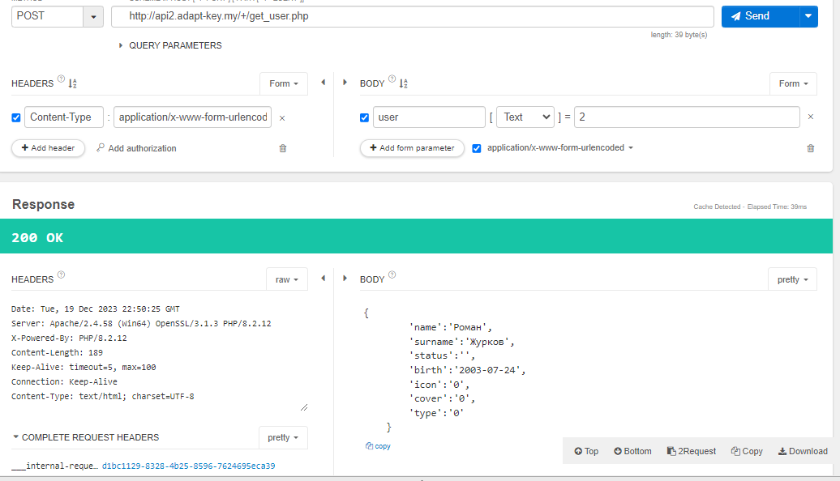
Рисунок 2 - пример работы программы

